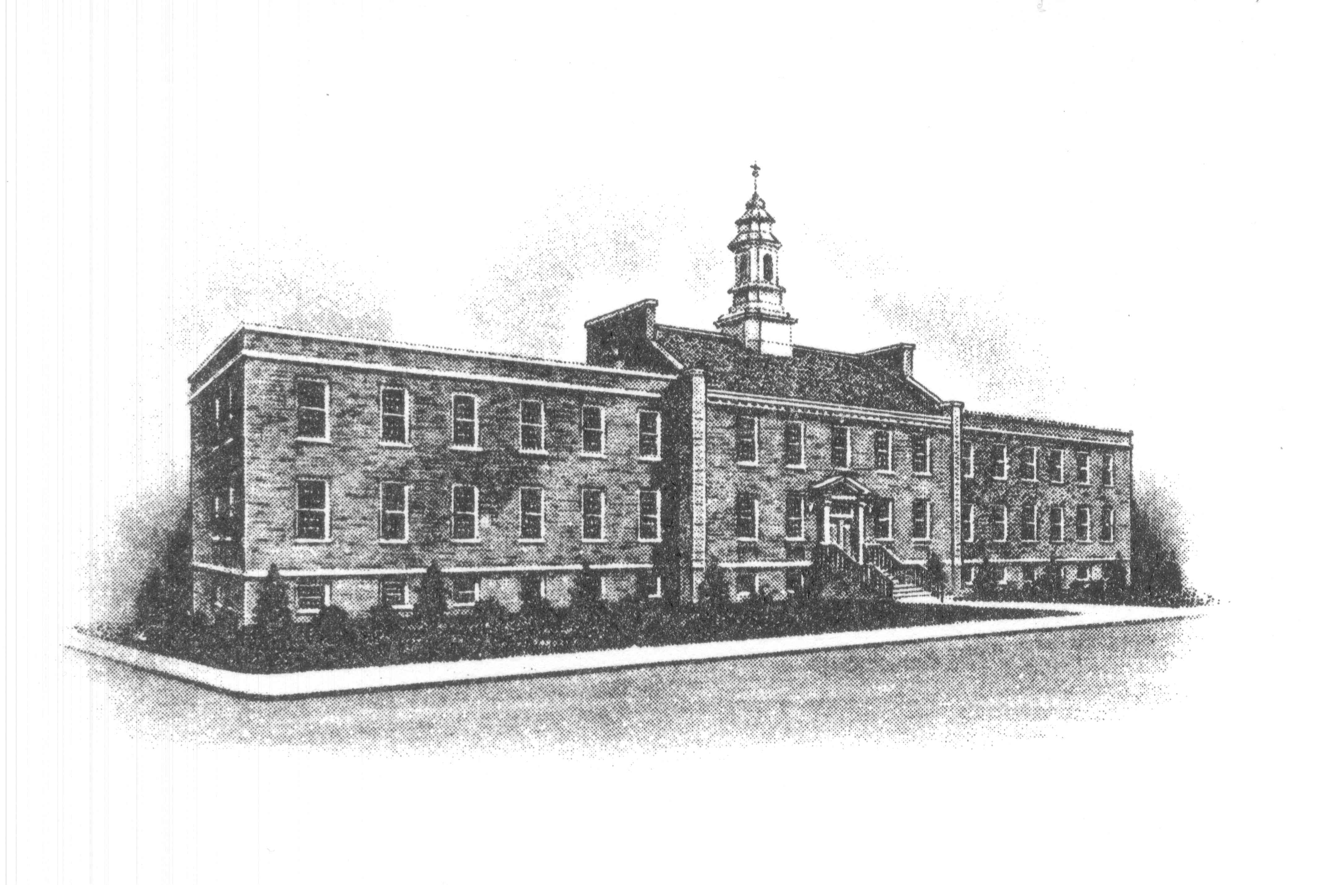

The Borough of Sayreville
167 Main Street
Sayreville, NJ 08872
732-390-7000

MEETING CANCELLATION

Please be advised that the Sayreville Economic & Redevelopment (SERA) meeting scheduled for tonight October 24, 2019 has been cancelled.

The next meeting will be on November 7, 2019.

Thank you.

Joan M. Kemble
Board Secretary
732-390-7077

